**FACT SHEET – STOCKTON HILL FIRE**

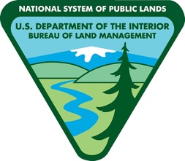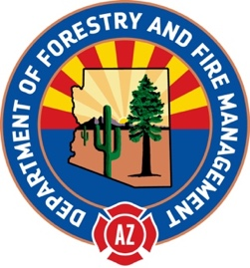

**Today’s Date:** 07/08/2023

**Start Date:** 07/04/2023 **Location**: 10 mi. N. Kingman **Cause:** Human-caused, under investigation

**Acres:** 589 **Containment:** 45%

**Evacuations**: SET – Red Wing Canyon, READY – Shadow Canyon

**Structures Damaged:** 0 **Destroyed:** 0

**Summary**: Friday’s high winds tested lines, but overall, they are holding well and crews will continue to strengthen and secure them over the next few days. Crews are also prepping a road and clearing fuel around it to serve as a contingency line north of the fire. That line ultimately helps further protect homes ahead of the fire. The northwest flank remains a priority as firefighters continue efforts to secure that side which is located in very rugged terrain within the Cerbats. Resources are also cold trailing around the fire’s perimeter to confirm there is no remaining heat. There is minimal smoke within the interior of the fire, but pockets of unburned fuel may still smolder. While evacuations have been downgraded, the public should use caution when driving in the areas of Red Wing and Shadow Canyons as crews move forward with suppression efforts in those areas.

**Resources and Personnel Assigned: 225**

**Type 1 Hand Crews**: 3, **Type 2 Hand Crews**: 3, **Type 3 Helicopters**: 2, **Engines**: 7, **Water Tenders**: 3

**Weather:** Hot and dry conditions with breezy southwest winds. Single digit relative humidity and triple digit temperatures in the extended forecast.

**Incident Information**: <https://inciweb.wildfire.gov/incident-information/aza5s-stockton-hill>

**Twitter**: @azstateforestry: <https://twitter.com/azstateforestry>

**Facebook**: Arizona Department of Forestry and Fire Management: <https://www.facebook.com/arizonaforestry>

**Media/Public Phone**: 602-540-1036